
Name: ___________________

Data for Decision-Making Student Handbook
Module 4: Introduction to Data Lifecycle – Analyzing and Sharing Data

Review:
- Data life cycle
- Data collection
- Data analysis
- Data sharing
- Metadata
- Primary data
- Secondary data
- Methods of data collection

Key Term: Data Lifecycle

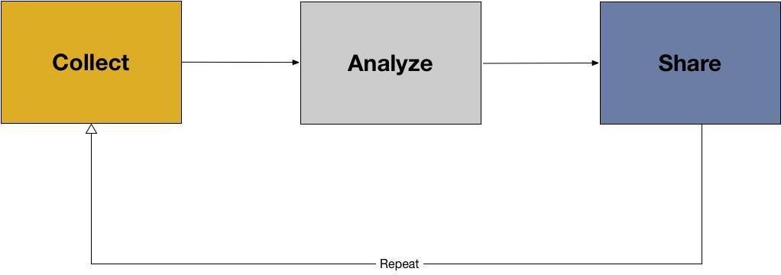

This image represents a data life cycle. There are three stages:

- Collecting data
- Analyzing data
- Sharing data

The last module focused on collecting data. This module will focus on analyzing and sharing data.

Key Term: Data Analysis

In the box below, write the definition for collecting data provided by the instructor.

The following are steps to follow in beginning any data analysis.

1. Choosing method for analysis.
- This can be thought of as making meaning of the data, or how you will use the data to answer your question or solve your problem.
- We want to choose a method that helps us answer our question or our overall goal.
- If we want to know, for example, which parties are most represented in state and region parliaments? To answer this we need election results data (including location information), and we probably want to produce this on a map.

2. Preparing data for analysis
- The next step is to prepare your data for analysis. Often, “raw data” straight from surveys, sensor data, or voter data can be “messy”, meaning it is not ready for analysis. To fix this, you often need to “clean” your data. Ask the participants what they think data cleaning might be. Then, provide the following definition:
- Data Cleaning means making sure that data are ready for analysis.

3. Data Normalization
- After cleaning, the next step is data normalization, which means making all values consistent.
- This includes ‘0’ vs ‘NA’, using similar scales, using similar decimal points, dates, words, etc. For location data, we also want to initially make sure that all of our data are within the right map and all locations are uniformly named.

We will cover three ways of making meaning with data in this workshop:
- Descriptive Statistics
- Coding qualitative data
- Visualization

Key Term: Descriptive Statistics

In the box below, write the definition for “descriptive statistics" provided by the instructor.

The following are descriptive statistics:
- Mean: the average or the norm

- Median: the middle value

- Mode: the most frequent value

- Range: the highest and lowest values in a dataset

The mean, median, mode, and range are measures of centrality and can offer a quick snapshot into the data without having to look at every single value.

Key Term: Coding

In the box below, write the definition for “coding” provided by the instructor.

Key Considerations in Data Analysis:

There are often many questions that a dataset can answer, and often you will think of more to ask as you continue to analyze your data.
- Choose one initial question. Write it down. As new questions emerge, continue to write these down, and only after you’ve answered the initial question should you come back to the “new” questions
- Do I have enough data?
- Do I trust the data that I have?
- Who collected these data? How? When were they collected? Is the sample size big enough?
- Always communicate how much data or what kind of data were used.
- Always communicate how you arrived at an answer, and what were the limitations of the data that were used.

Sample Resources for Data Analysis:

Making Meaning: Quantitative
- Easy to use template for Google Sheets: https://docs.google.com/spreadsheets/d/1GwAGqhipP6CdeyGuk3dZEl004H8C24JkSMki50lu5kI/template/preview?usp=drive_web#
Making Meaning: Qualitative
- Card Sorting Templates: http://uxmastery.com/store/card-sorting-analysis-spreadsheet/
- Qualitative data coding http://onlineqda.hud.ac.uk/Intro_QDA/how_what_to_code.php
- Online (free) tool for coding: http://www.dedoose.com/
Making Meaning: Visualization
- Basic Principles: http://paldhous.github.io/ucb/2016/dataviz/week2.html
- Combine Google Sheets and Google Charts: https://developers.google.com/chart/
- Tableau Public (free tool) https://public.tableau.com/s/

Key Considerations in Sharing your Data:

To share your data, you should prepare the data into digital formats that can be easily sharable across organizations. Data should always be put into “open formats”. These include:
- Text: .txt; docx. PDF
- Image: JPEG, PNG
- Audio: Mp3
- Video: MP4

Creating documentation: Remember

- Metadata: structured information that describes, explains, locates, or otherwise makes it easier to retrieve, use, or manage data. Metadata can also be call data about data, or information about information. (National Information Standards Organization, 2013)
- Descriptive Metadata - who created the data, when, where, what kind of data are these, and what topics / subjects do they contain?
- Administrative Metadata - how were the data produced, using what methods of data collection, and what instruments?
- Rights metadata - Who can use what resource, how , and under what conditions? (how to choose a license: https://choosealicense.com/)

Free services for data archiving:

- Figshare: https://figshare.com/
- Zenodo: https://zenodo.org/

Key Concepts: Data Visualization

The following image provides a best practices for what type of chart to use given the information that you want to communicate.

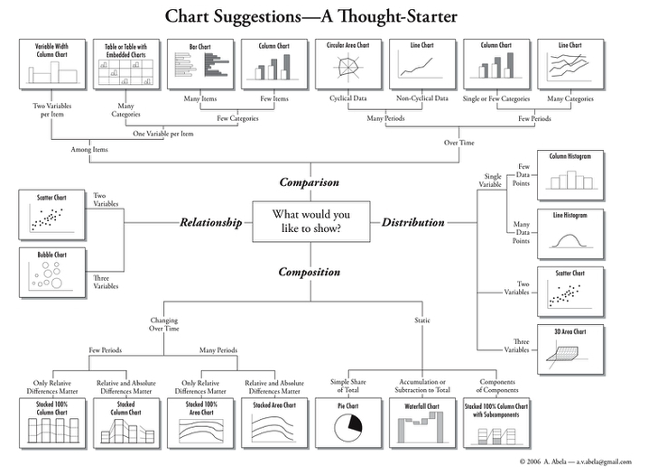

Other best practices for data visualizations include:

- Label all axis
- Create a legend that tells viewers what data are being used, and any limitations (e.g.sample size)
- Create a descriptive title
- Provide a link to the original data, or contact information for the data producer.

