Activity 3.2 Data Collection with Google Forms

Objectives:
- Create a survey using Google Forms
- Understand how to design a survey, the types of questions that can be asked, and how to view responses
- View response in Google Sheets, and use these responses for your own analysis

Total anticipated time: 30 mins

Materials Needed:
- Shared Computer
- Paper
- Pencils
- Google Account

Introduction: (Use the following information to introduce and explain the activity to the class)

Google Forms are free and openly accessible digital tools that can be used to design a survey. For our benefit, many of these tools work together – so we can use Forms to collect data, and we can use Sheets to view aggregated data.

In this example, we are going to design a simple survey for the sake of collecting data about people’s experience attending a movie. We want to understand what is typical of their experience.

Surveys are a valuable instrument for collecting data when doing evaluation, gathering information about an unknown subject, or generally understanding users behaviors. Some additional features that make for a good survey are as follows:

- The population is known, and can be separated (differentiated) in some meaningful way, such as by
  - Age
  - Gender
  - Income level
  - Education level
- You have a small set of questions that you want each participant to supply
- The questions you want answered are simple, and have straightforward answers
- The responses might vary by the type of participant

Survey questions can take a variety of forms – the most common types of questions that can be asked are:
- Multiple choice - participants choose from a set of examples
  - When asking many multiple choice, or check-box questions, you can also use a “grid” format to ask many questions in a row. We will look at an example of this in our first exercise.
- Rank order - participants are asked to rank a set of options
- Likert scale – a participant is able to offer a judgement based on a numerical value (e.g. 1 being the best, and 5 being the worst)
- Open ended or Short answers – a participant is given the opportunity to, in their own words, respond with an explanation.
To create a new google form:
- Log into your Google Drive account
- Go to https://docs.google.com/forms
- We can either create a new form, or select an existing template
For the first exercise, let’s select the “Exit Ticket” template
  - Here we see an example of a form that allows participants to leave Short Answer responses about their experience in a class.
  - Notice that in designing the form you can click on an individual question
    - This gives you the option to change the type of question that is being asked, edit the text of the question.
    - You can also select whether the question is “Required” meaning it has to be answered by each participant, delete, or duplicate the question.
    - To move questions around in order, simply drag the 6 dots at the top of the question

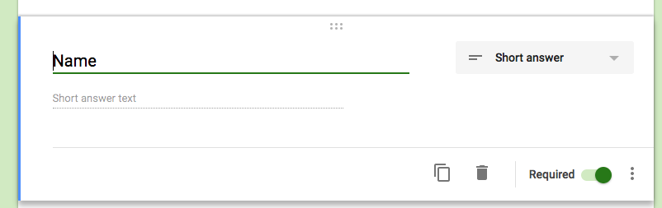
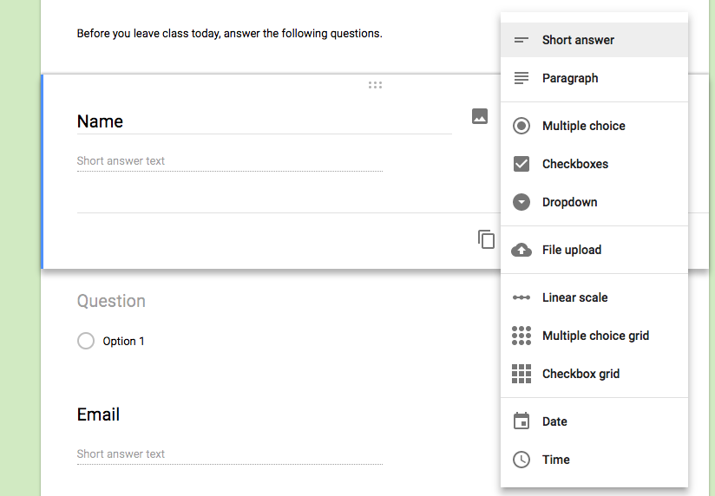

  - After we have finished designing our form, we can also see what the responses will look like by clicking the ‘RESPONSES’ tab.
    - The responses can be viewed by a Summary of all responses, or by each individual response
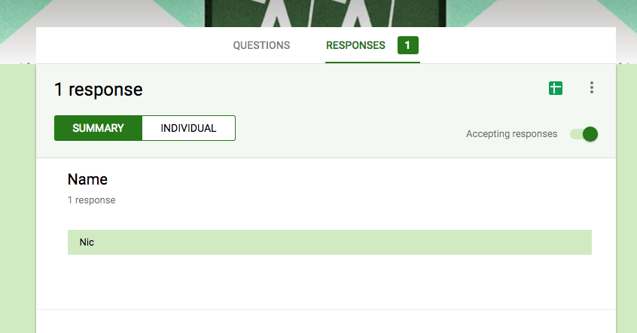

  - It will be hard to use this information within the Form itself. To create a spreadsheet of all answers we can click the green button with a cross (the spreadsheet button). This will give us the option to create a google Sheets form to view our answers. Click the Sheets button and create a new sheet with the responses.

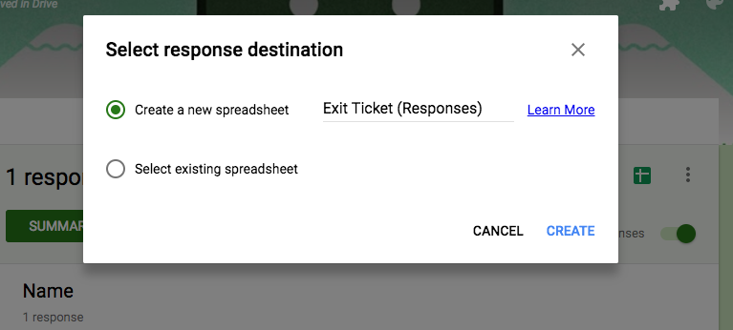

  - The Sheet that opens has each question as a Column, and each row as a response to our questions. So, we can now view (in aggregate) all responses to our questions.

